PROJECT REPORT

# TITLE NAME: ***TRACING THE GROWTH OF GLOBAL COMMUNITY : A POPULATION FORECASTING ANALYSIS***

1.INTRODUCTION:

**1.1.OVERVIEW:**

**Over the last 200 years, the world’s population has grown rapidly. Whereas there only lived around one billion people on the Earth in the early 19th century, the total population is estimated to reach eight billion in 2023. Since 1975, the planet’s population has almost doubled. Furthermore, the number of people is Expected to continue to increase over the coming decades, reaching over 10 billion by 2060, before flattening more in the latter half of the 21st century. Population in the world is, as of 2022, growing at a rate around 0.84% per year.**

**1.2. PURPOSE:**

**The main purpose of forcasting population is increase people’s awareness on various population issues such as the importance of family planning, gender equality, poverty maternal health and human rights. Population growth will lead to economic growth with more people able to produce more good**

**2.PROBLEM DEFINITION:**

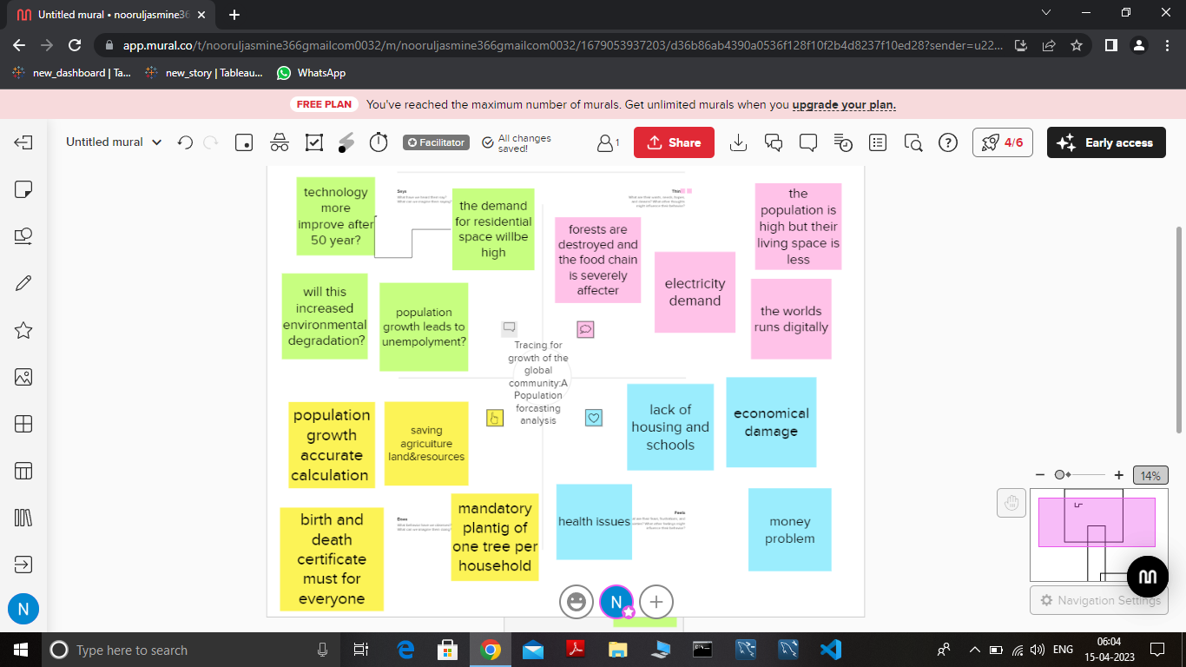

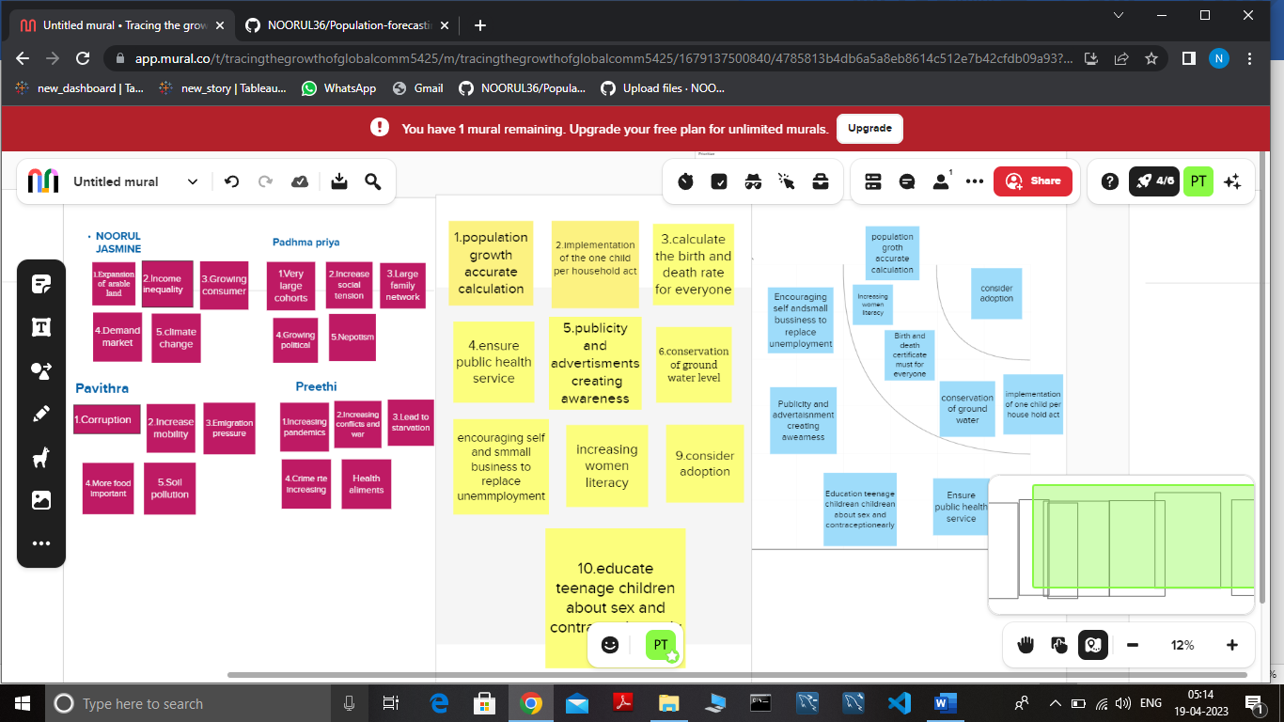

3.RESULT: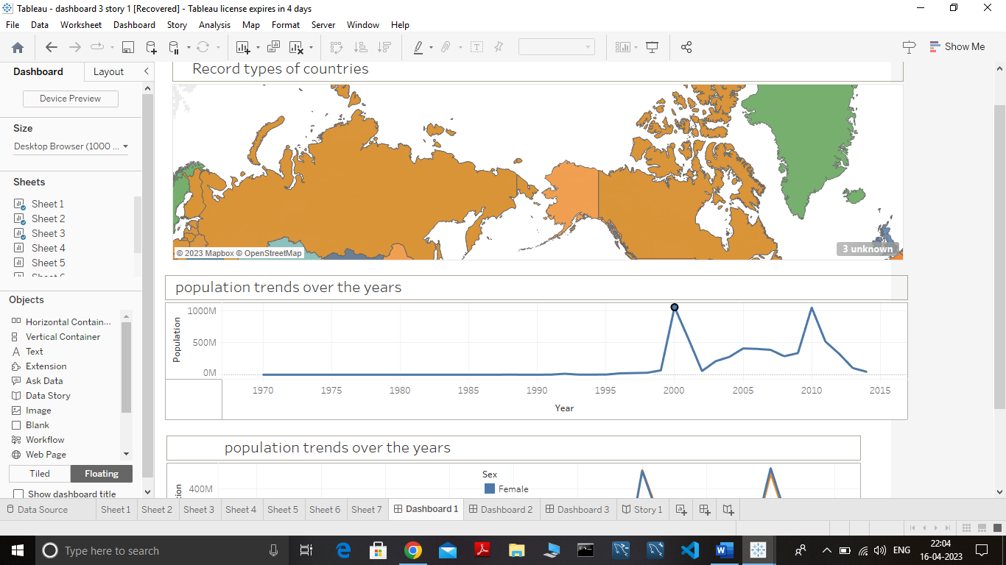

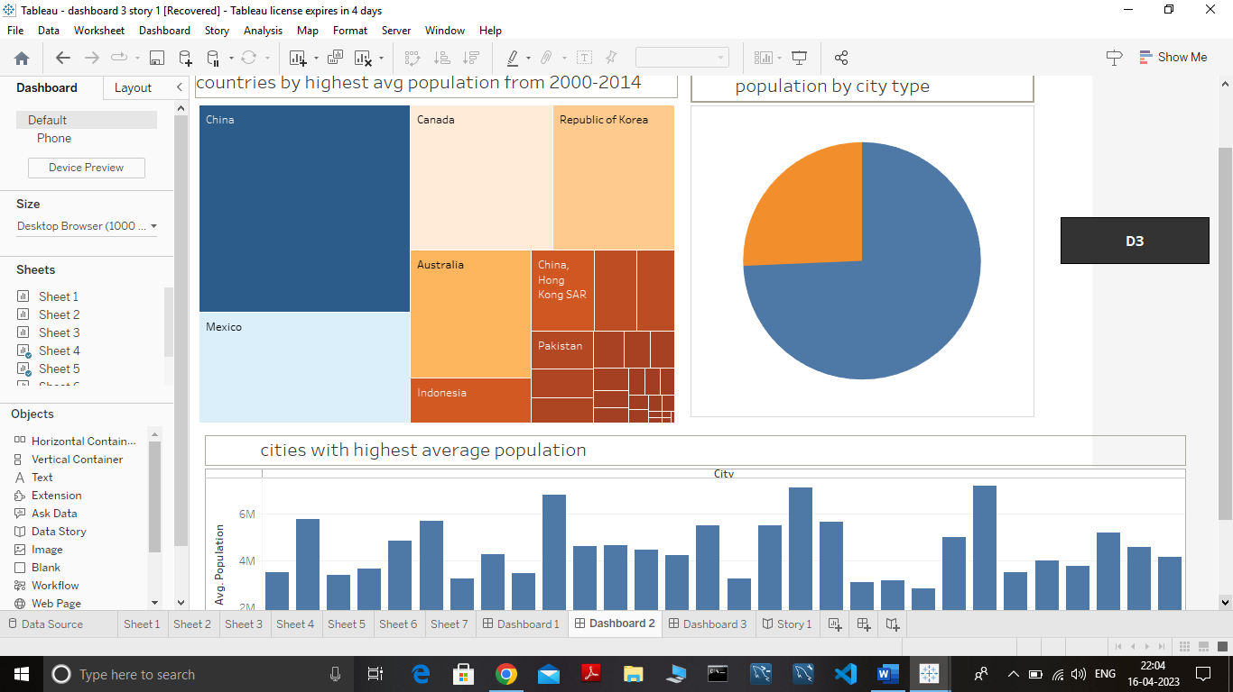

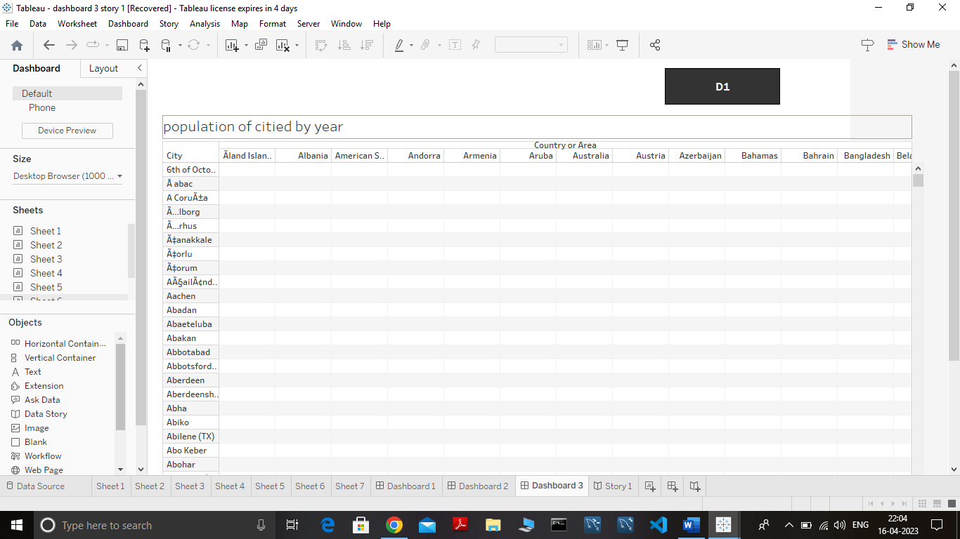

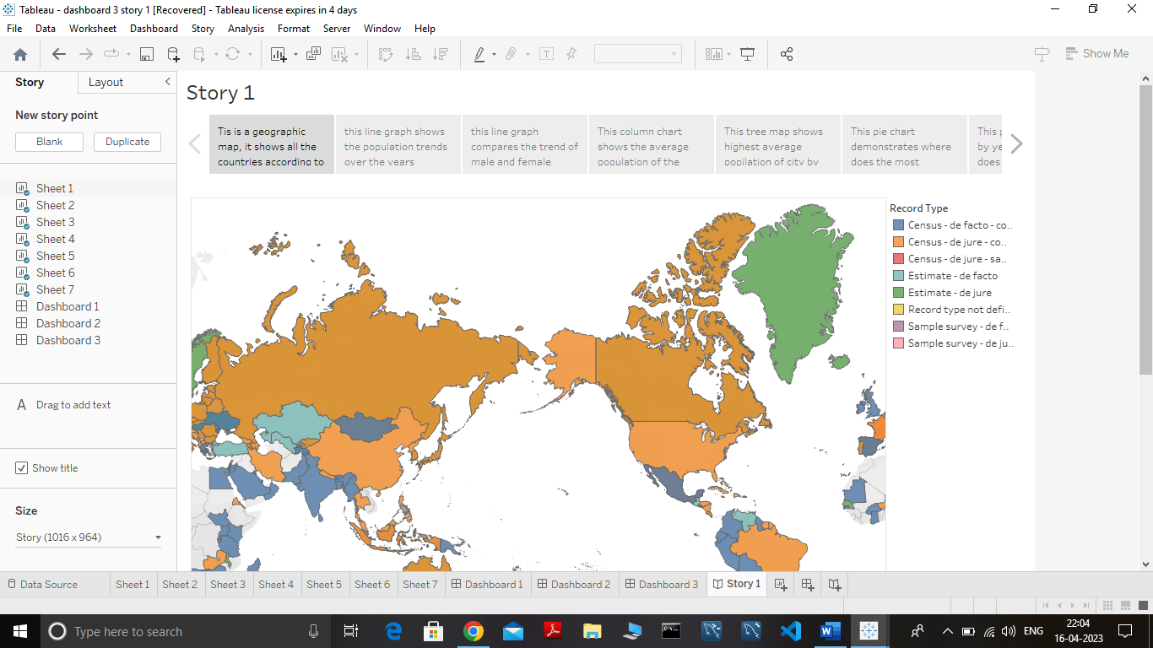

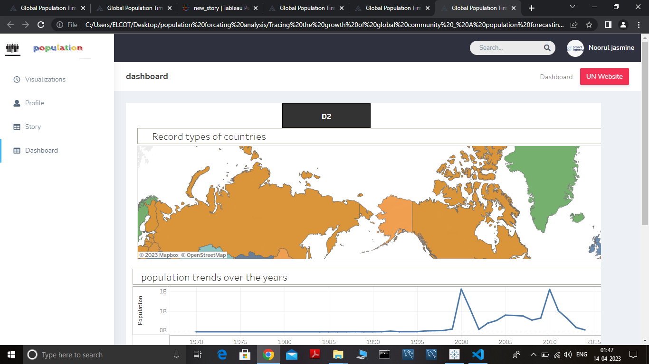

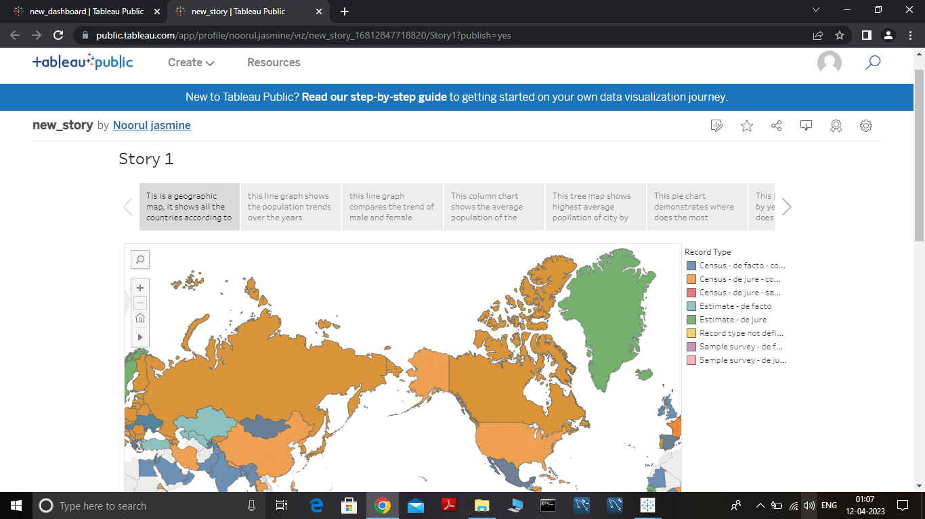

4.ADVANTAGES & DISADVANTAGES:

4.1 ADVANTAGES:

* Access to New Markets
* Economic growth with people able to produce more goods.
* Provides many Opportunities for businesses to capitalise on, given its vast consumer base.
* Spread of knowledge and Technology

4.2 DISADVANTAGES:

* + - Higher population will lead to greater consumption of non-renewable resources, leading to a faster depletion of nature resources.
    - Over crowding,destitution,crime,pollution,and political turmoil.
    - A rise in the dependency ratio which would increase the economic pressure on the workforce.
    - Thses population are never accurate.

5.APPLICATIONS:

* Marketing, E-commerce, Banking,Finance, Human resource, Production, and Information technology.
* Provide potentially powerful explanations for the phenomena of organizational birth, mortality,and evolution.
* To provide an estimate of the future population as a common framework for yse in planning,policyy formation and decision making in a number of different fields.
* Collect taxes and allocate the proper amount of funding to various infrastructure and social programs.improve for technology.

6.CONCLUSION:

Forecast uses item-level data and predicts future sales in terms of both item quantities and sales amount.The project gives a graph of furure size and structure of the population by sex ,age by several countries.its past datas anf future assumption like econamic problem ,unempolyment.

7.FUTURE SCOPE:

* Realise the human rights of all, achive gender equality and the empowenment of all womens and girls and ensure the lasting protection of the planet and its natural resources.
* Enhances the economic growth of a country.
* You can make reliable estimate of the population with less time effort,and money.
* This forecasting more access to labor,which will lead to higher productivity, which then will lead to more goods being produced.

BY

K.NOORUL JASMINE

B.PADHMA PRIYA

D.PAVITHRA

T.PREETHI